

ARRAYS

Assignment # 13-15

JAVASCRIPT

1. Declare an empty array using JS literal notation to store student names in future.

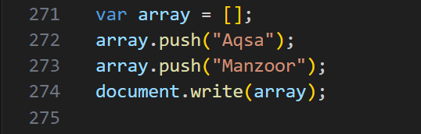

1. Declare an empty array using JS object notation to store student names in future.

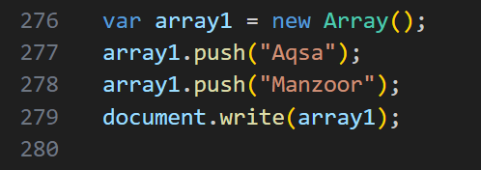

1. Declare and initialize a strings array.

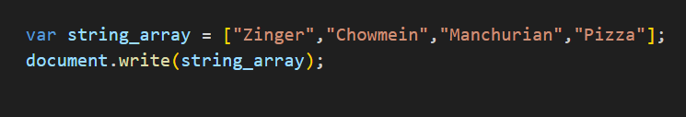

1. Declare and initi alize a numbers array.

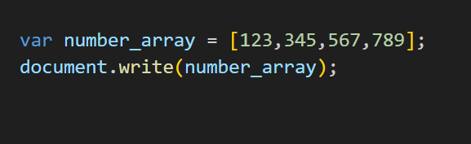

1. Declare and initialize a boolean array.

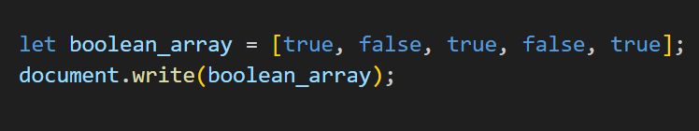

1. Declare and initialize a mixed array.

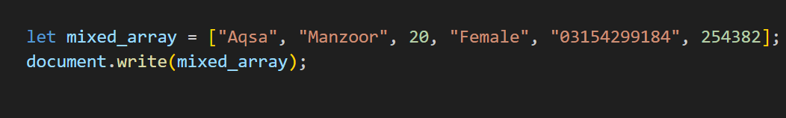

1. Declare and Initialize an array and store available education qualifications in Pakistan (e.g. SSC, HSC, BCS, BS, BCOM, MS, M. Phil., PhD). Show the listed qualifications in your browser like:

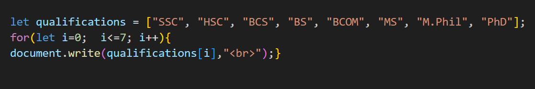

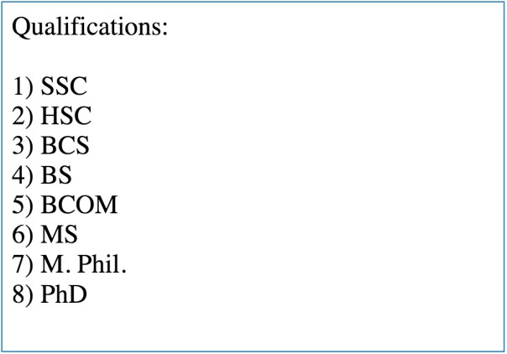

1. Write a program to store 3 student names in an array.Take another array to store score of these three students. Assume that total marks are 500 for each student, display the scores & percentages of students like:

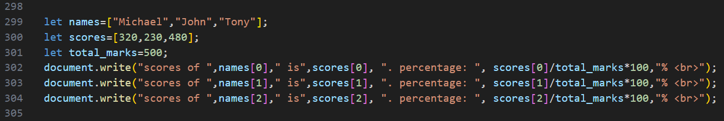



1. Initialize an array with color names. Display the array elements in your browser.
   1. Ask the user what color he/she wants to add to the beginning & add that color to the beginning of the array. Display the updated array in your browser.

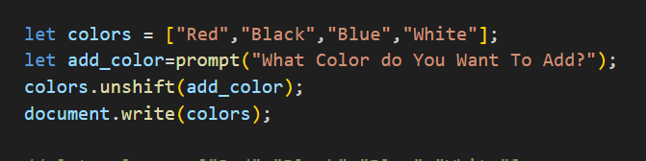

* 1. Ask the user what color he/she wants to add to the end & add that color to the end of the array. Display the updated array in your browser.

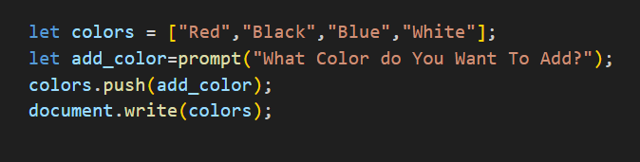

* 1. Add two more color to the beginning of the array. Display the updated array in your browser.

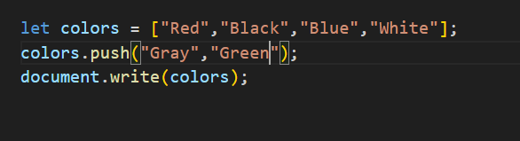

* 1. Delete the first color in the array. Display the updated array in your browser.

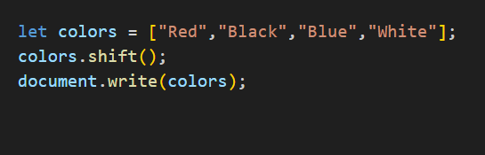

* 1. Delete the last color in the array. Display the updated array in your browser.

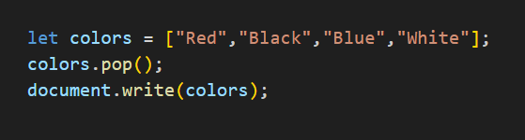

* 1. Ask the user at which index he/she wants to add a color & color name. Then add the color to desired position/index. . Display the updated array in your browser.

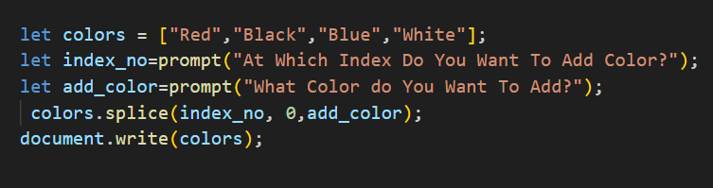

* 1. Ask the user at which index he/she wants to delete color(s) & how many colors he/she wants to delete. Then

remove the same number of color(s) from user-defined position/index. . Display the updated array in your browser.

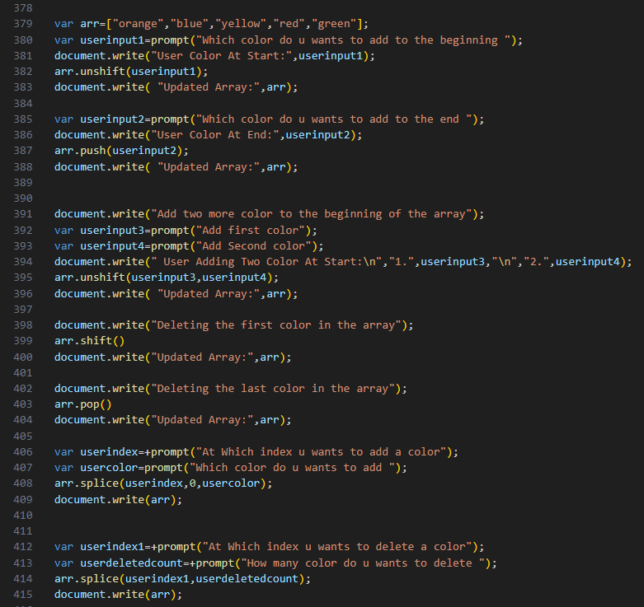

1. Write a program to store student scores in an array & sort the array in ascending order using Array’s sort method.

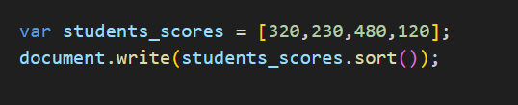

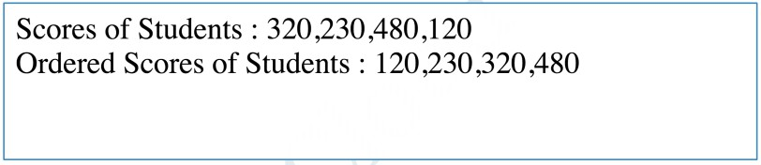

1. Write a program to initialize an array with city names. Copy 3 array elements from ***cities*** array to ***selectedCities*** array.

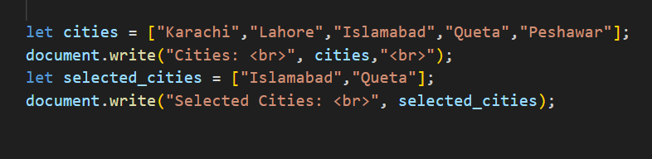

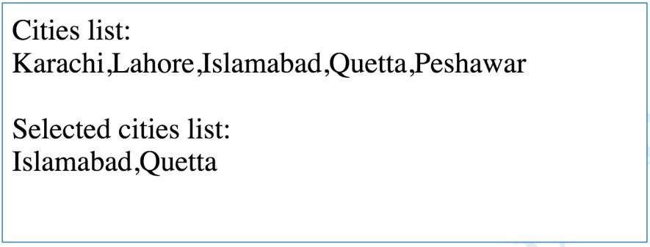

1. Write a program to create a single string from the below mentioned array:

var arr = [“This ”, “ is ”, “ my ”, “ cat”]; (Use array’s join method)

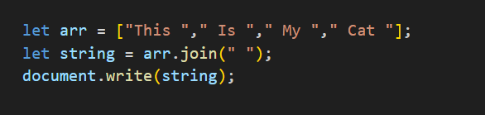

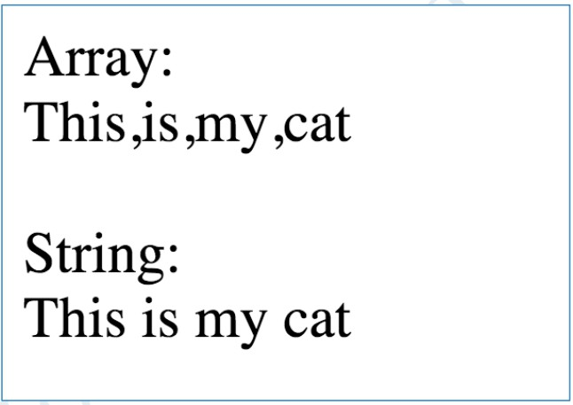

1. Create a new array. Store values one by one in such a way that you can access the values in the order in which they were stored. (FIFO-First In First Out)

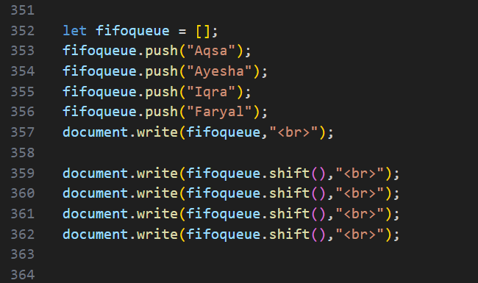

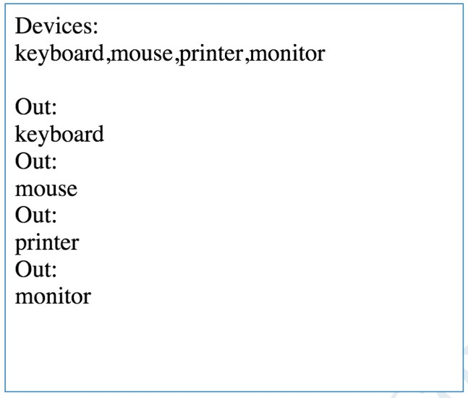

1. Create a new array. Store values one by one in such a way that you can access the values in reverse order. (Last In- First Out)

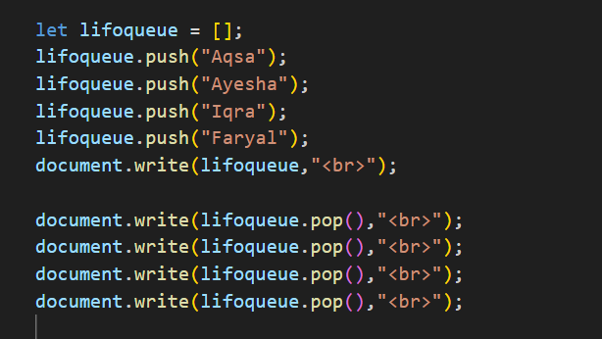

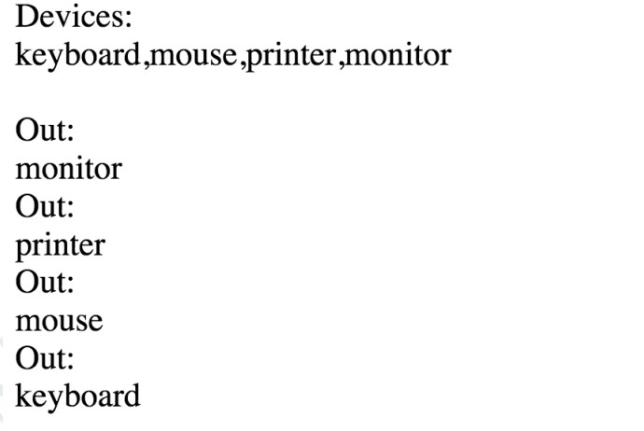

1. Write a program to store phone manufacturers (Apple, Samsung, Motorola, Nokia, Sony & Haier) in an array. Display the following dropdown/select menu in your browser using document.write() method:

